Name:Vishnu Vijayakumar
Roll No: 53
Batch: RMCA B
Date: 06-06-2022

NETWORKING & SYSTEM ADMINISTRATION LAB

Experiment No: 25 Aim
TCP dump Procedure Commands:
$ sudo update && sudo apt install tcpdump

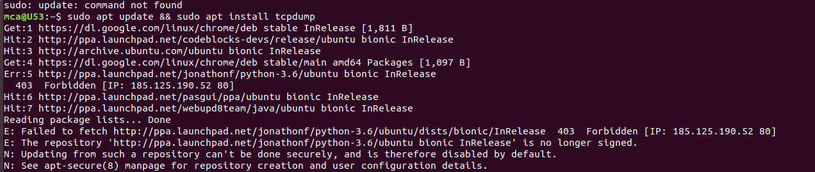

$sudo tcpdump
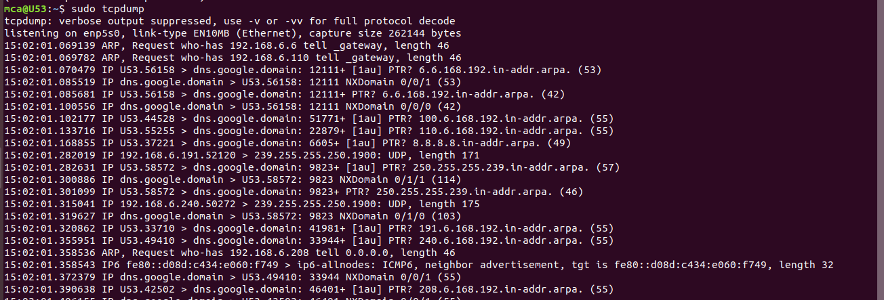

$ sudo tcpdump –D
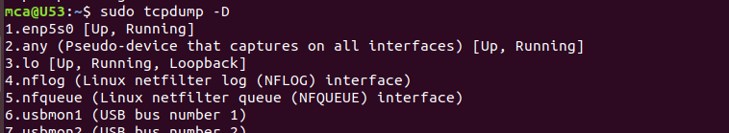

$ sudo tcpdump –i enp5s0
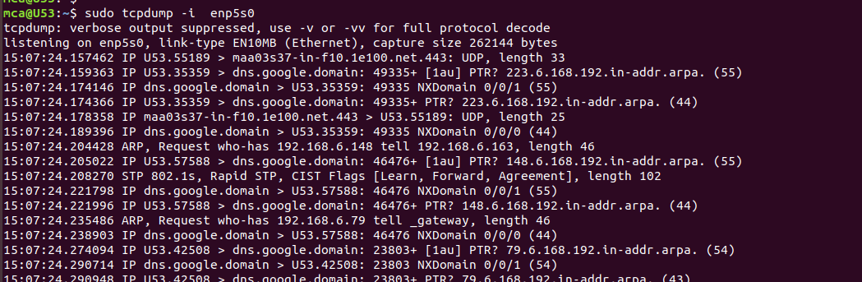

$ sudo tcpdump –c n –I enp5s0
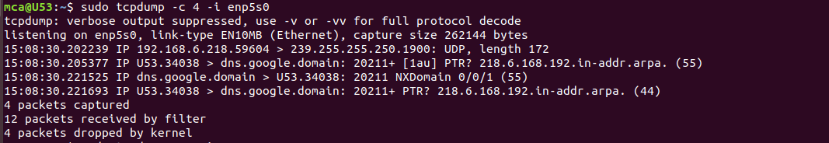

$ sudo tcpdump –xx –I enp5s0
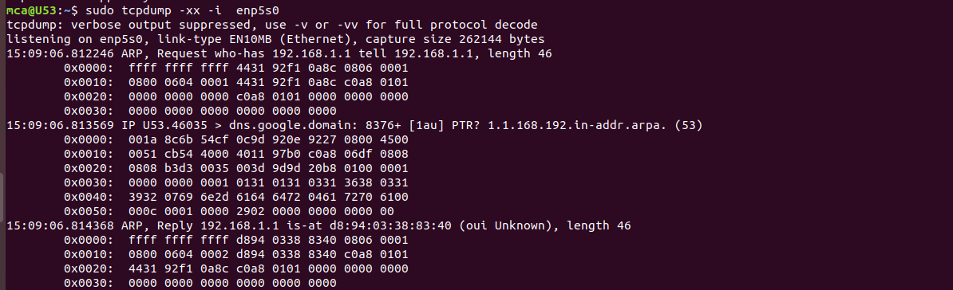

$ sudo tcpdump –i enp5s0 -c n port 80
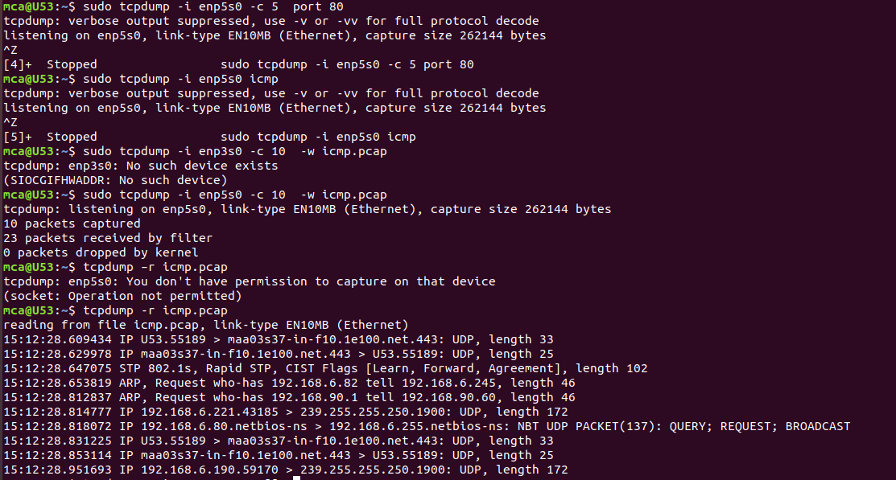

$ sudo tcpdump –i enp5s0 icmp

$ sudo tcpdump –i enp5s0 –c n –w icmp.pcap

$ tcpdump –r icmp.pcap

